ANTI-MONEY-LAUNDERING DETECTION ON THE ELLIPTIC BITCOIN GRAPH
Phase-wise Flowchart Documentation
Raw data and EDA through to directional residual Bayesian graph neural networks

This document renders the full research lifecycle as a set of four flowcharts. Each diagram is self-contained and carries the metrics that justify the transition to the next stage, so the figures can be lifted directly into a thesis chapter, a review deck, or an internal design document.
What the four diagrams cover
Figure 1 — the master lifecycle from raw dataset to deployable alerts. Figure 2 — the ingestion and preprocessing path that turns three CSV files into a leakage-free PyTorch Geometric graph. Figure 3 — the multi-pass pseudo-labelling loop that recovers the missing 77.15% of node labels. Figure 4 — the internal forward flow of the final directional residual Bayesian GNN.

How to read the diagrams
- Colour encodes stage: navy for data and orchestration, teal for preprocessing and message passing, crimson for the failed sparse baseline, amber for decisions and training-signal components, green for validated outputs.
- Solid arrows carry data or tensors forward. The dashed arrow in Figure 4 is the residual skip-connection, which re-injects the raw 165-dimensional feature vector rather than passing a transformed one.
- The diamond in Figure 3 is the only branching decision in the pipeline; every other step is unconditional.
- Metrics printed inside a node are measured on the test split (timesteps 35 to 49) unless the node states otherwise.

Figure 1 — Master lifecycle flow
The end-to-end spine of the project. Each phase box states what was built and what was measured; each arrow states the finding that forced the next phase. The crimson-to-amber transition is the pivot of the whole study — the point at which sparse supervised evaluation was abandoned in favour of full topological recovery.
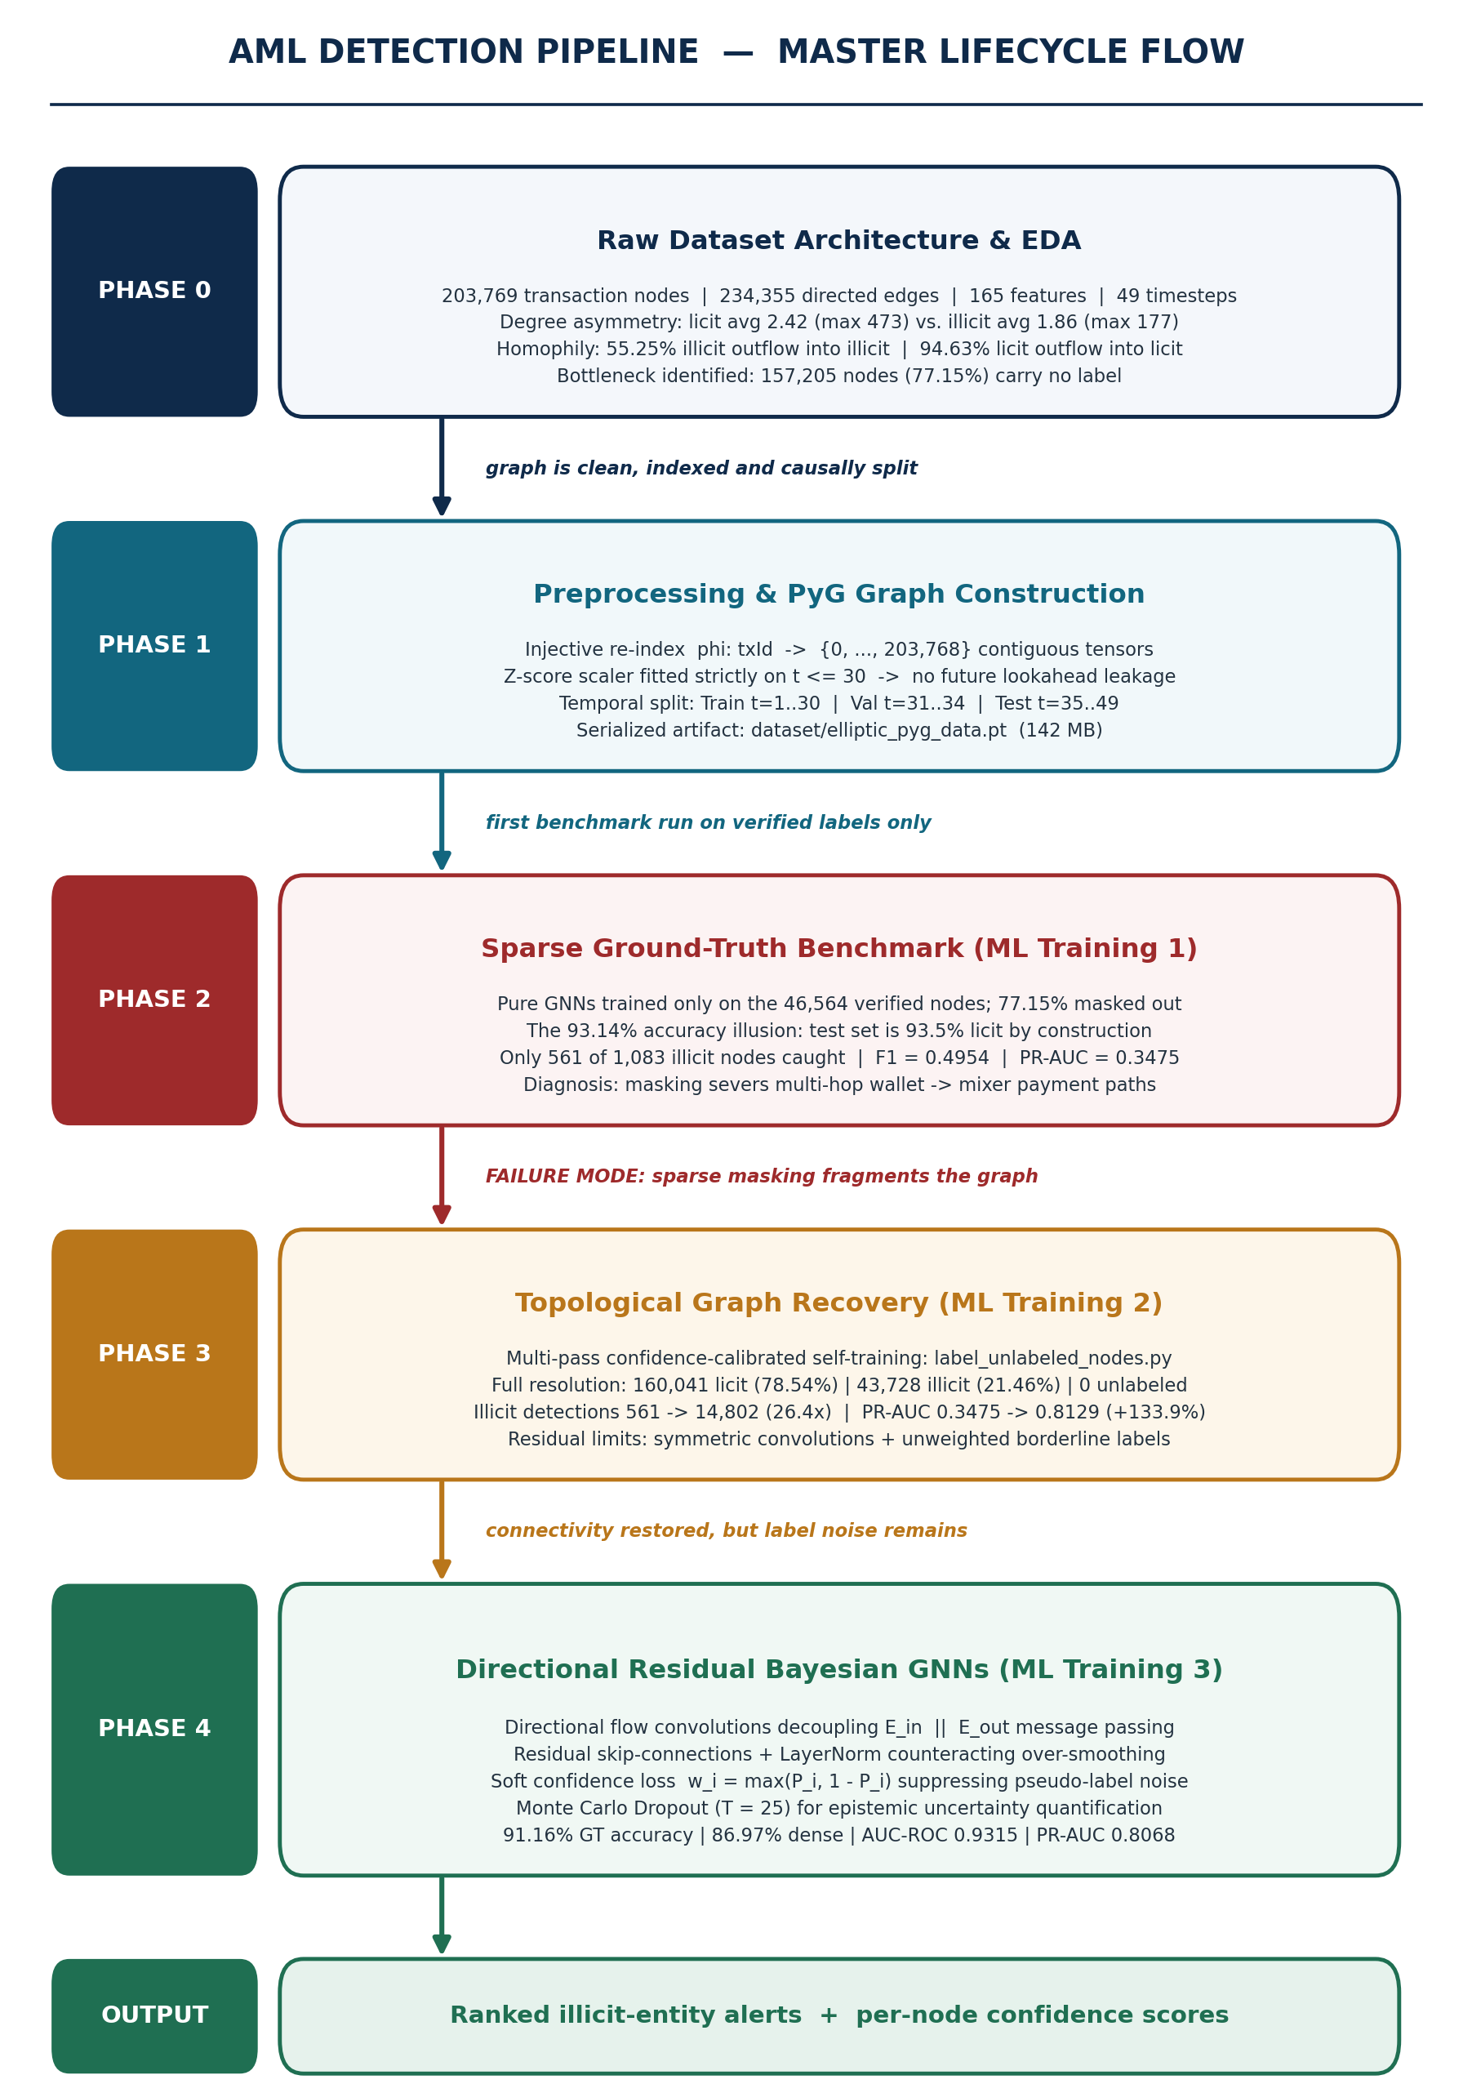
Figure 1. Phase 0 to Phase 4 lifecycle, with the diagnostic finding that triggers each transition.

Figure 2 — Ingestion and preprocessing path
Three raw CSV files converge into a single serialized graph object. Two constraints dominate this stage: the z-score scaler is fitted only on timesteps up to 30, so no distributional information from the future leaks backwards, and the split is temporal rather than random, so the model is never asked to interpolate between transactions it has already seen.
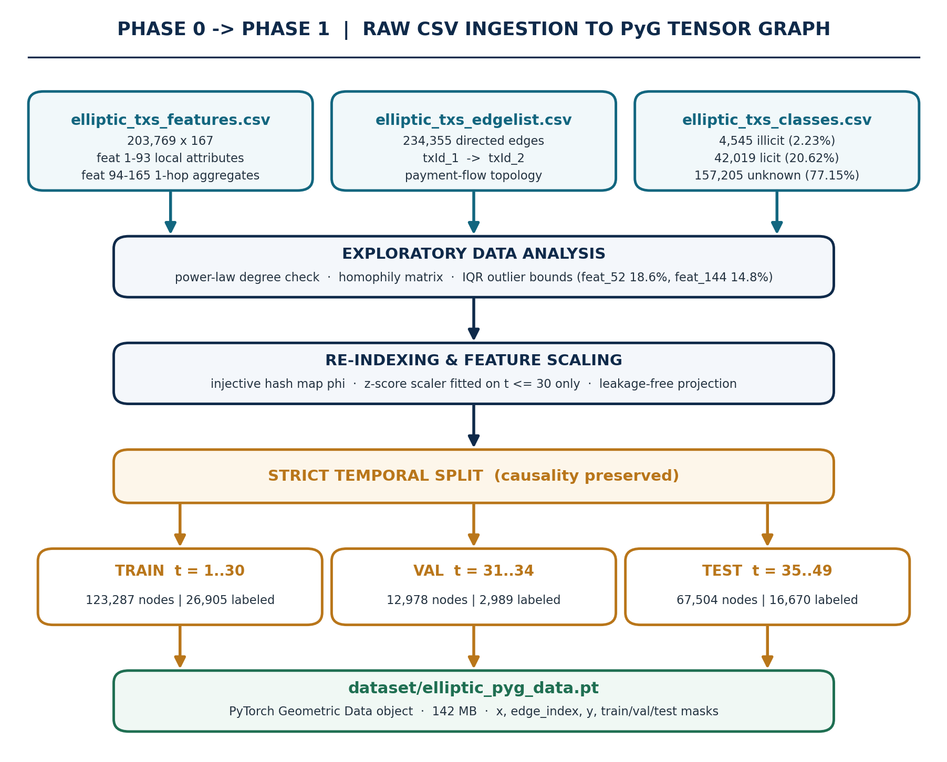
Figure 2. Raw CSV ingestion, EDA, re-indexing, leakage-free scaling and the strict temporal split.

Reading notes
- Features 1 to 93 are local transaction attributes (fees, input and output counts, BTC volume); features 94 to 165 are 1-hop neighbourhood aggregates, which is why even a shallow GNN already sees two hops of context.
- The injective map φ exists purely to convert string transaction hashes into contiguous integer indices so that edge_index can be expressed as a coordinate tensor.
- The 77.15% unlabeled share is visible here but is not acted on until Phase 3; Phase 2 deliberately runs with it masked out to establish the baseline.

Figure 3 — Pseudo-labelling recovery loop
This is the only cyclic structure in the pipeline. A GNN is trained on whatever labels currently exist, predicts a probability for every unlabeled node, and commits only those predictions that clear a calibrated confidence threshold. Nodes below the threshold are held back and re-examined on the next pass, once their neighbourhood has been partially resolved and the message-passing signal reaching them has improved.
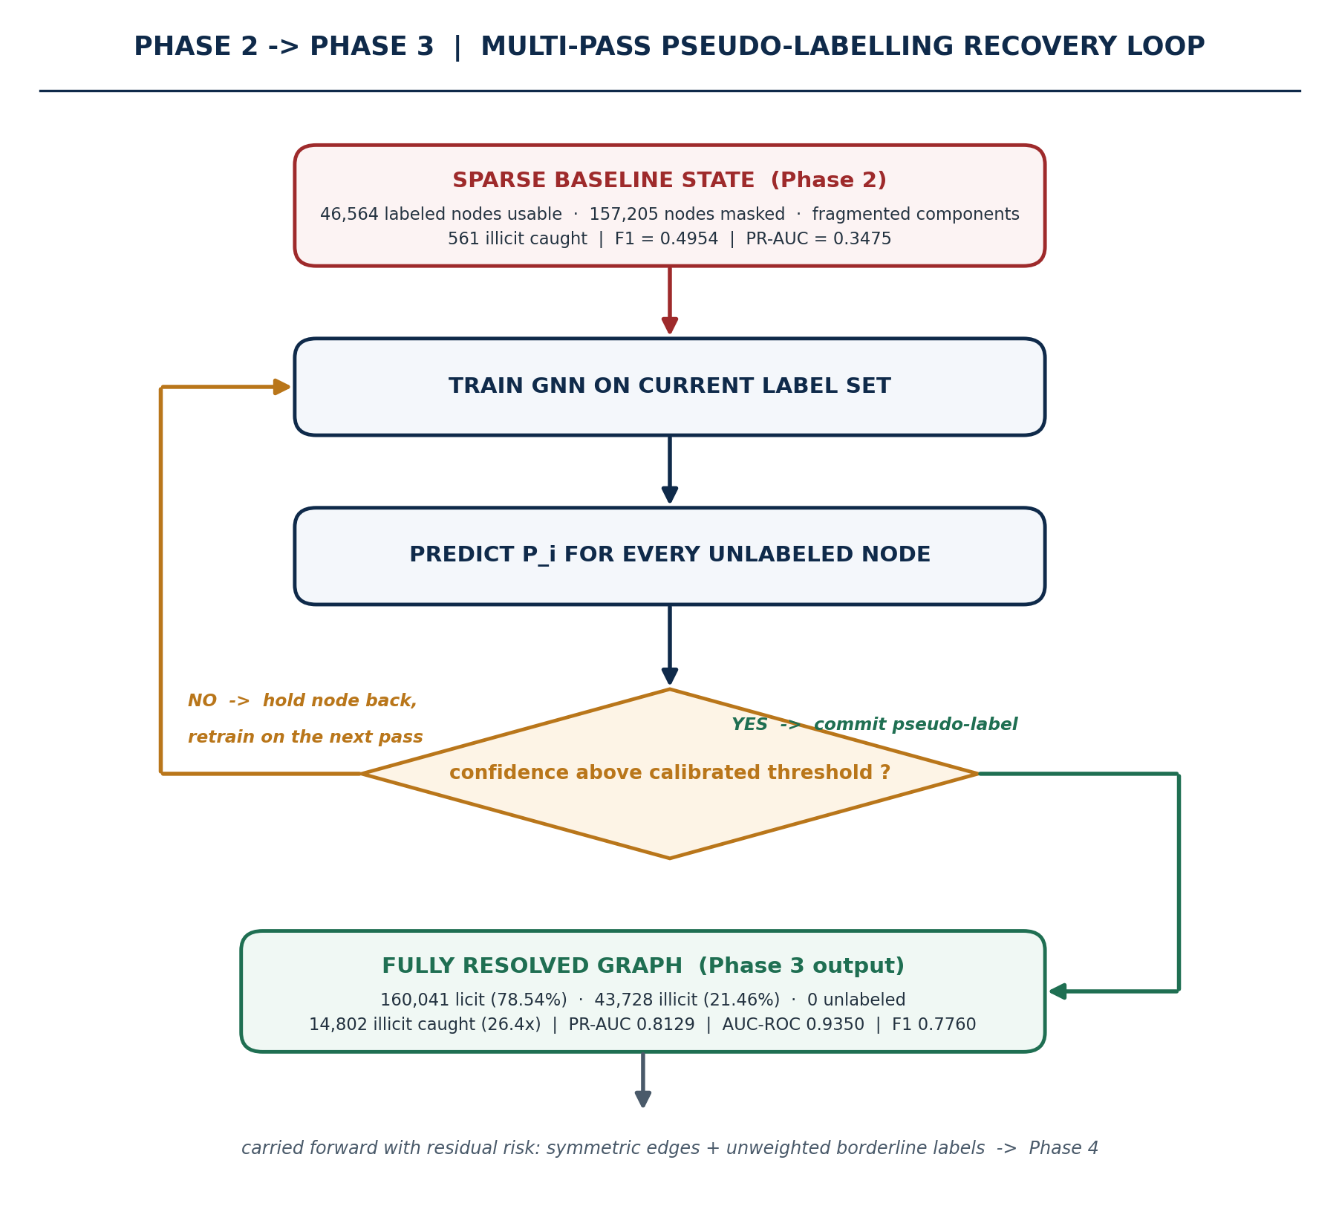
Figure 3. Multi-pass confidence-calibrated self-training, from the fragmented baseline to a fully resolved graph.

Reading notes
- The 26.4x jump in illicit detections is a connectivity effect, not a modelling one: restoring the masked nodes reconnects the multi-hop paths between source wallets and downstream mixers.
- The loop terminates when no held-back node clears the threshold on a further pass, leaving zero unlabeled nodes.
- The residual risk carried into Phase 4 is that a committed pseudo-label near the threshold contributes the same gradient weight as a forensically verified label — which is precisely what the soft confidence loss later corrects.

Figure 4 — Directional residual Bayesian GNN, forward flow
The final architecture separates inbound from outbound message passing. A node that collects funds from many senders and a node that disperses funds into many receivers have opposite laundering semantics, and a symmetric convolution averages that distinction away. Decoupling the two and concatenating their embeddings preserves it.
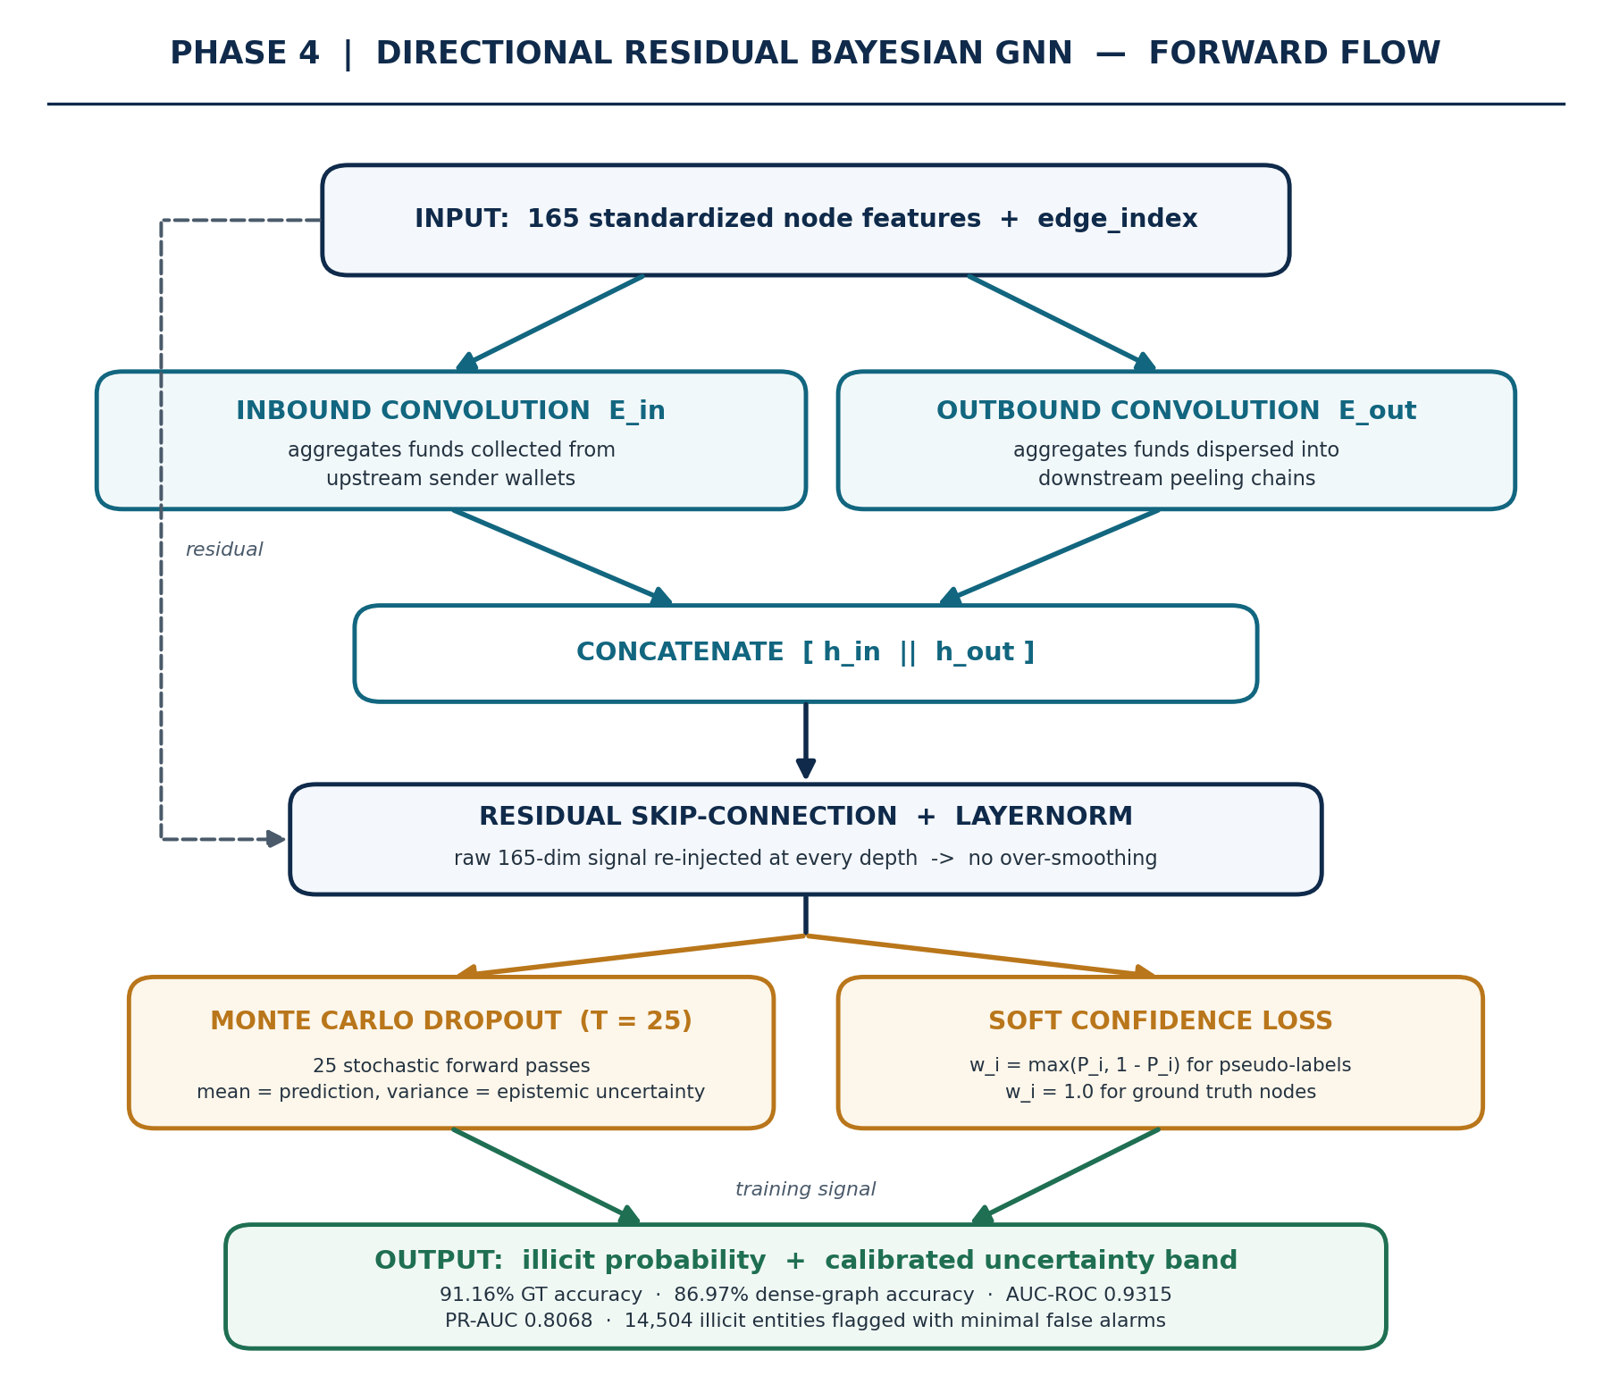
Figure 4. Directional convolutions, residual skip-connection, Monte Carlo Dropout and the soft confidence loss.

Reading notes
- E_in aggregates over incoming edges (funds collected); E_out aggregates over outgoing edges (funds dispersed into peeling chains). Their concatenation is what lets the model distinguish a collection point from a dispersal point.
- The residual path keeps the raw feature signal available at every depth, which is what allows the network to be deepened without collapsing into over-smoothed, near-identical node embeddings.
- Monte Carlo Dropout runs 25 stochastic forward passes at inference. The mean is the prediction; the variance is the epistemic uncertainty, which is what makes the output triage-ready — a high-probability, low-variance node is worth an investigator's time, a high-probability, high-variance node is worth a second model.
- The soft confidence weight w_i = max(P_i, 1 − P_i) equals 1.0 for ground-truth nodes and falls towards 0.5 for borderline pseudo-labels, so uncertain labels contribute proportionally smaller gradients.

Cross-phase comparative synthesis
The same evaluation protocol applied across the three training regimes. Read the table alongside Figure 1: each column is one of the phase boxes, and the row-wise movement explains why each arrow in that figure exists.

Dimension / metric | Phase 2 — sparse | Phase 3 — 100% pseudo | Phase 4 — directional + soft
Node label coverage | 22.85% (46,564) | 100% (203,769) | 100% (203,769)
Graph topology | Disconnected fragments | Fully connected | Connected + asymmetric flow
Edge convolutions | Undirected | Undirected | Directional (E_in ⊕ E_out) + skips
Loss function | Class-weighted BCE | Class-weighted BCE | Soft confidence-weighted BCE
Illicit entities detected | 561 | 14,802 | 14,504
Test PR-AUC (illicit) | 0.3475 | 0.8129 | 0.8068
Test AUC-ROC | 0.8391 | 0.9350 | 0.9315
Ground-truth accuracy | 93.14% (skewed) | 86.85% | 91.16%
Dir-ResGCN AUC-ROC | 0.7963 | 0.9162 | 0.9249
Dir-ResSAGE AUC-ROC | 0.8407 | 0.9180 | 0.9195
Uncertainty estimation | MC Dropout (T=20) | MC Dropout (T=20) | MC Dropout (T=25), directional
Operational verdict | Incomplete baseline | Connectivity breakthrough | Operational standard

Interpreting the accuracy columns
Phase 2's 93.14% is the highest raw accuracy in the table and the least informative number in the study: a test set that is 93.5% licit can be almost matched by predicting the majority class everywhere. PR-AUC on the illicit class is the honest comparator, and on that measure Phase 2 scores 0.3475 against Phase 4's 0.8068. Phase 4 then recovers accuracy to 91.16% on ground truth without giving back the precision-recall gains.
Phase 3 and Phase 4 are close on headline discrimination (PR-AUC 0.8129 against 0.8068), which is expected — Phase 3 already solved the binding constraint, which was connectivity. What Phase 4 adds is not raw separation but trustworthiness: directional semantics, noise-weighted gradients, and a calibrated uncertainty band on every prediction.

